If you forgot your password to NIIB application, please make the following steps:

1. Send a message by WhatsApp to the number +7 965 218-55-74 indicating your request and family name.
2. An SMS from NIPBank will be sent to the number specified during registration (Russian phone number) with one-time password for the initial login to the Internet Banking system.

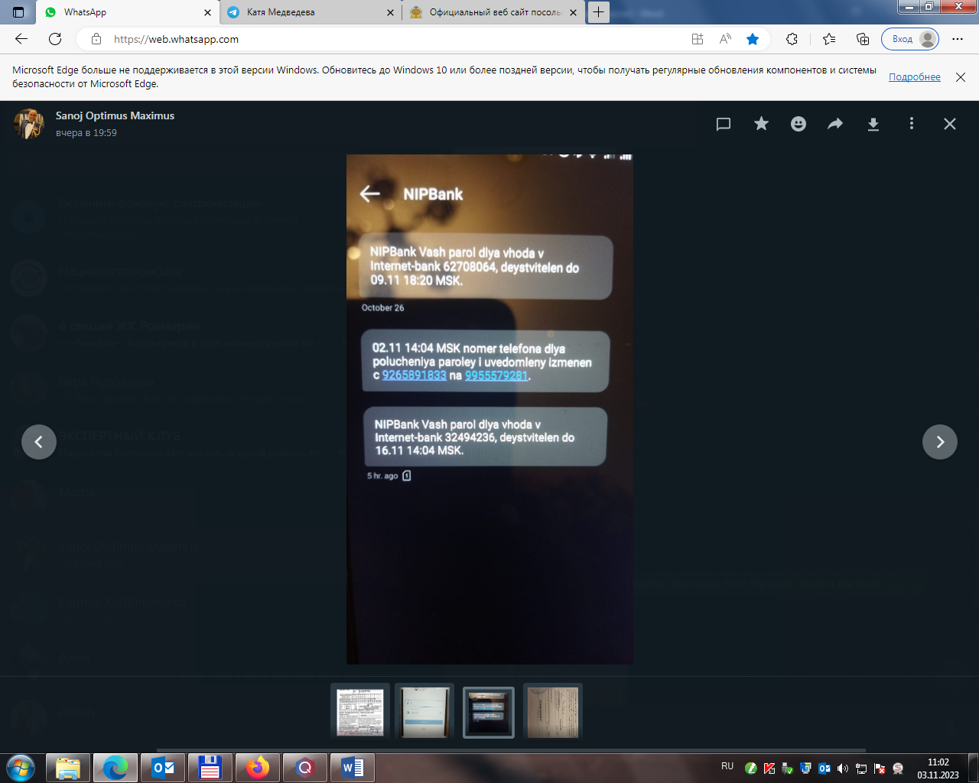



It means:

NIPBank your password to log in the internet-bank 32494236, is valid until 16.11.2023 14:04 MSK time.

(It is an example only! Do not use it in your application!)

1. Put the password from the SMS into the application. Make sure that your login starts with **nip_**

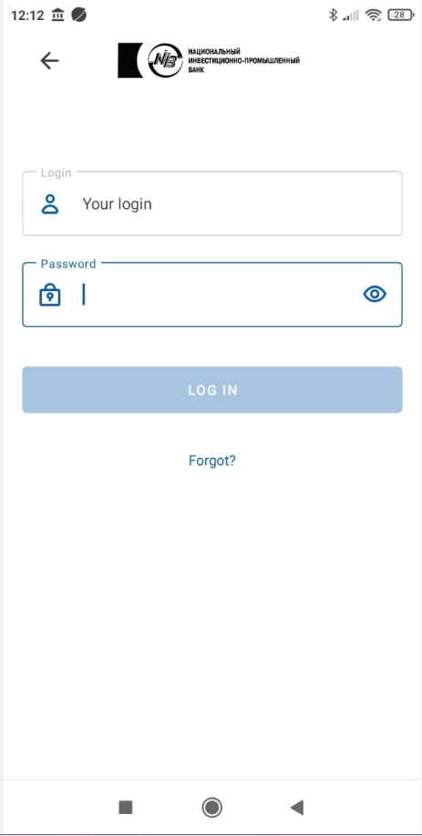

nip_ANTHONI

1. You will be offered to set the constant password. For this, indicate your old password (one-time password from the SMS), then new password which should be more than 8 symbols, contain one capital letter, one digit, one symbol (-, !, % ). For example: Anthoni-2023. Then input the new password one more time. Press CONFIRM button.
2. You will receive SMS with the confirmation code to change the password.
3. After that, you will be offered to set 4 digits to enter the app without login and constant password.

**If you forgot your login, please send a message by WhatsApp to the number +7 965 218-55-74 indicating your request and family name.**